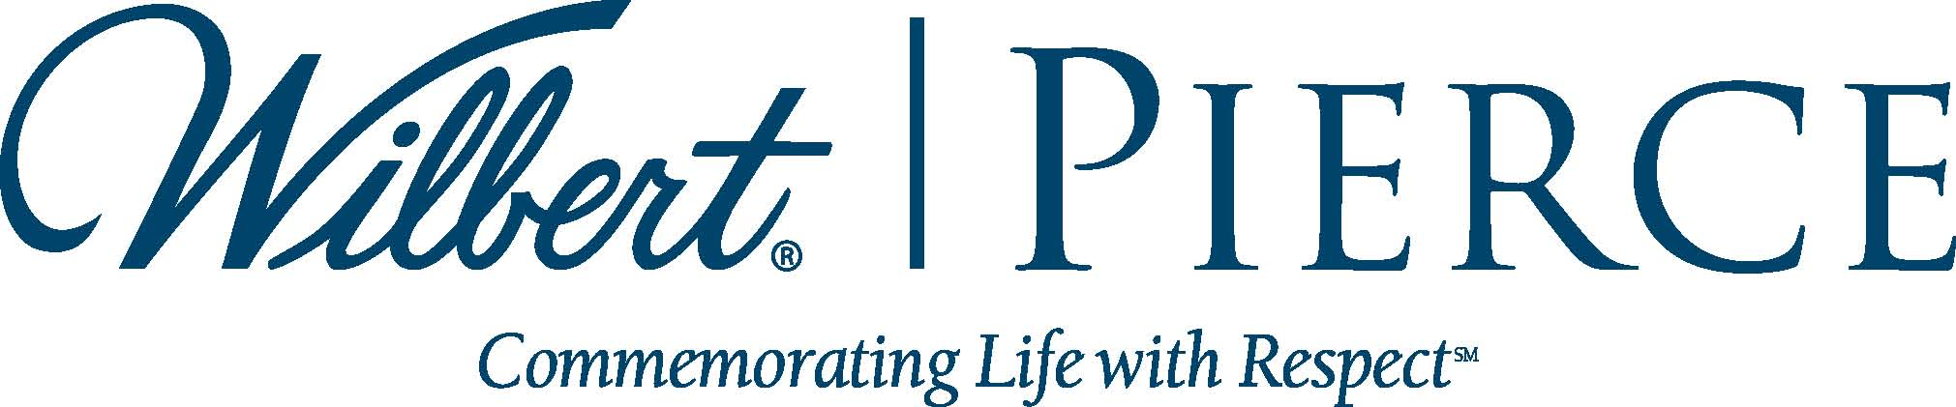
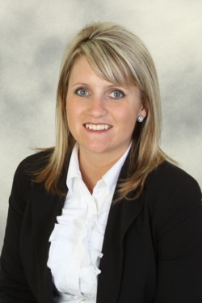

pierce chemical Welcomes
New sales representative ABBY SHURTZ

BROADVIEW, IL, APRIL 1, 2014 – Wilbert Funeral Services’ Pierce Chemical group, a leading provider of chemicals and other products for preparation rooms, is pleased to announce the addition of Abby Shurtz as Sales Representative for the Dallas-Fort Worth area and the eastern region of Texas. Shurtz will also be representing the Signet Supply line of high-quality wood and metal caskets.
Shurtz has over ten years of experience in the funeral industry, most recently as a funeral director and embalmer at Smith Family Mortuaries, Derby, Kansas. While there, she was a four-time recipient of the National Funeral Directors Association’s Pursuit of Excellence Award. Shurtz was also active in the Kansas Funeral Directors Association, including serving as president for District 4.
Shurtz holds a degree from the Kansas City Kansas Community College Mortuary Science program.
“Abby Shurtz is dedicated to the industry and with her background will be able to directly relate to the funeral professionals she will be serving,” said Lance Ray, Executive Vice President of Sales. “We are pleased to have Abby join the team and are confident she will provide top-notch service.”
Pierce Chemical products include embalming and accessory chemicals, cosmetics, tables, aspirator machines, water control units, instruments, safety equipment and personal protection products. Chapel supplies are also available through the Pierce group, including casket pedestals, church trucks, signs, cards, flag cases and many other items.
Signet Supply provides a variety of caskets that are positioned to fill the gap between cost and quality, creating value for both funeral professionals and the families they serve.
Shurtz can be reached at 214.460.9135 or ashurtz@wilbert.com. For more information on Pierce Chemical, call 800.527.6419 or visit www.piercechemical.com. For information on Signet Supply, call 913.345.2120 or visit www.signetsupply.com.

