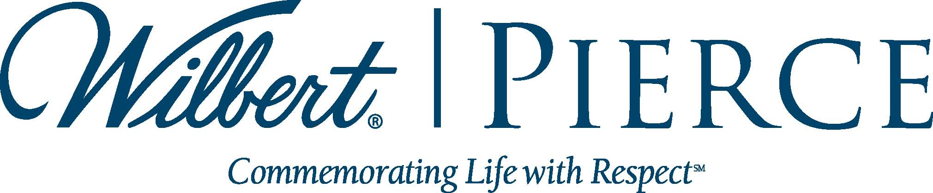
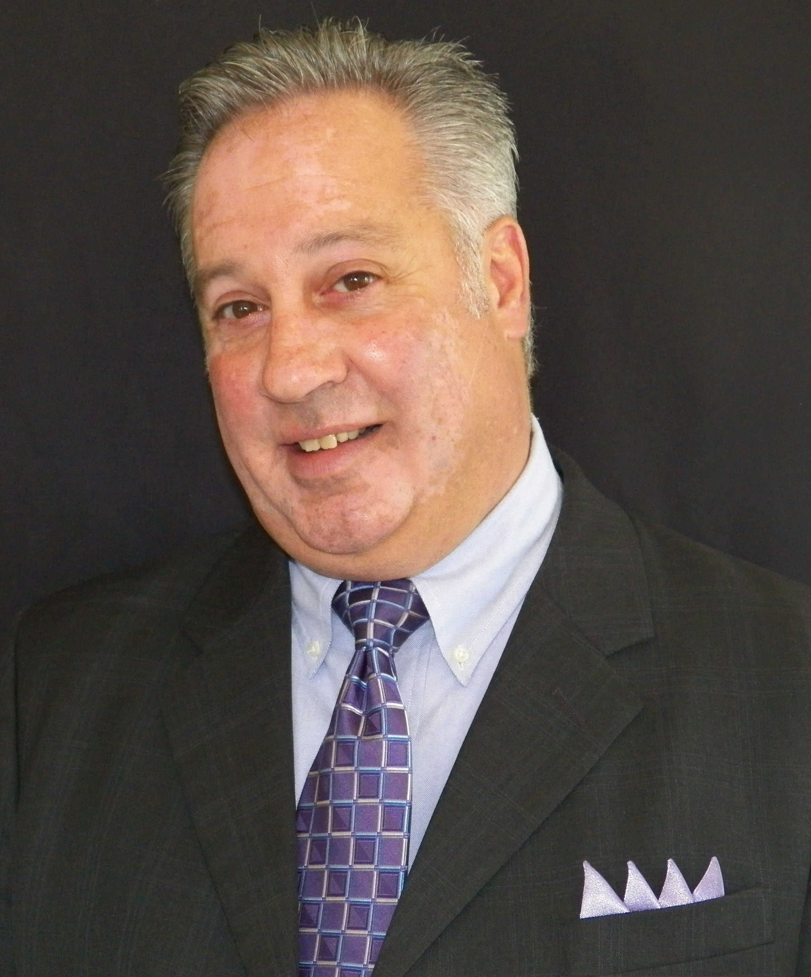

pierce chemical Welcomes
New sales representative angelo frazetta

BROADVIEW, IL, JULY 3, 2013 – Wilbert Funeral Services’ Pierce Chemical group, a leading provider of chemicals and other products for preparation rooms, is pleased to announce the addition of Angelo Frazetta as Sales Representative for the Northeast territory of the United States, including eastern Pennsylvania and the states of New Jersey, New York, Connecticut, Massachusetts, New Hampshire, Vermont and Rhode Island.
Frazetta has been in the funeral industry for over twenty-five years, with his most recent position as sales representative for Aurora Casket Company. He began his career as a first-generation funeral director, working at independently-owned funeral homes, and remains a licensed funeral director in Pennsylvania.
Frazetta is a graduate of the Pittsburgh Institute of Mortuary Science and also holds a Bachelor of Arts degree in Psychology from the University of Pittsburgh.
“With Angelo’s know-how and applied experience in embalming and other facets of funeral service, Pierce customers can turn to Angelo with confidence,” stated Lance Ray, Executive Vice President of Sales. “He can provide seasoned guidance along with fresh ideas to help his customers, and Pierce is fortunate to have Angelo on our team.”
Pierce Chemical products include embalming and accessory chemicals, cosmetics, tables, aspirator machines, water control units, instruments, safety equipment and personal protection products. Chapel supplies are also available through the Pierce group, including casket pedestals, church trucks, signs, cards, flag cases and many other items.
Frazetta can be reached at 732.619.9051 or afrazetta@wilbert.com. For more information on Pierce Chemical, call 800.527.6419 or visit www.piercechemical.com.

