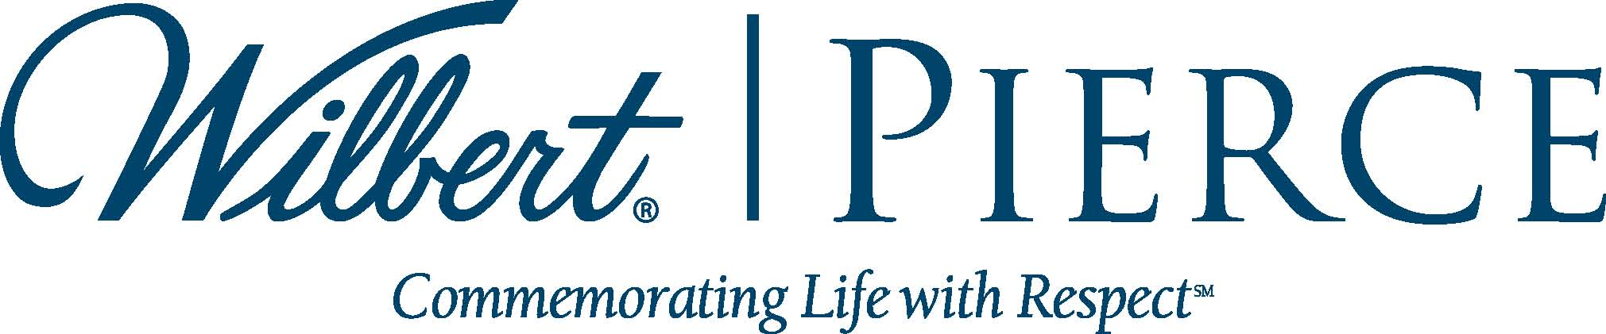
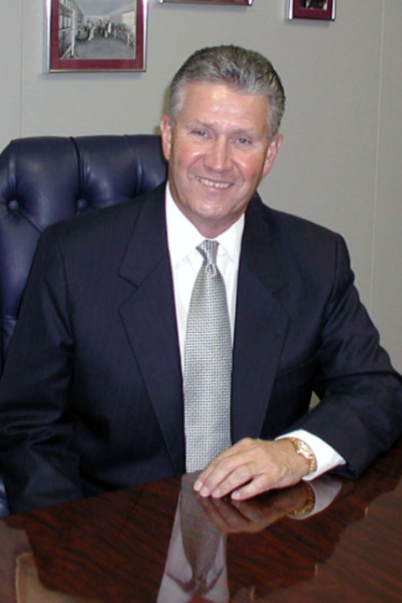

Wilbert-pierce congratulates
john firestone
for fifty years of dedicated service

BROADVIEW, IL, JULY 30, 2013 – Wilbert Funeral Services’ Pierce Chemical group congratulates John Firestone, long-time president, chairman and CEO of the Pierce Companies, on his 50th anniversary with the company.
John has even more than fifty years in the funeral industry, working as a child to help his grandfather put temporary grave marker nameplates together for a penny-per-piece to make some spending money. He continued working in the industry throughout his high school summers (presumably making a little bit more money).
John began his career with Pierce Chemical in July of 1963 upon receiving a call from his uncle and company founder Bill Pierce the same day he was discharged from the Marine Reserves in which he’d enlisted after college, asking John to come work full-time. Three days later, John had packed his belongings, drove from Dallas to Atlanta, and began his full-time career with Pierce. John worked in every department over his history with the company, from blending products to the shipping room to doing the books. He earned his place as chairman through many years of hard and dedicated work, helping guide the success of Pierce through product expansion and market growth.
John also taught at the Pierce Mortuary Colleges, later serving as chairman and CEO and helping shape the curriculum to address the evolving needs of the funeral professional.
“John is truly an industry leader who has earned the respect of both Pierce employees as well as industry colleagues for his insight and effective leadership,” said Joseph Suhor, Chairman of the Board, Wilbert Funeral Services. “I have had the pleasure to know John for many years and consider him among the best in the industry as well as a friend. Our sincere congratulations and thanks go out to John for his service to Pierce and the industry.”
For more information on Pierce Chemical, call 800.527.6419 or visit www.piercechemical.com.

