PURPOSE
The purpose of this program is to provide education on heat illnesses, including how the body handles heat, the different types of heat illnesses and specific risk factors. XXXXXXX recognizes the potential problems caused by high temperatures in the work environment. To protect the well-being of all employees and reduce the potential for heat-related illnesses, this program has been developed to provide XXXXXXX locations with strategies to help ensure a safe and healthy workforce.

SCOPE
This program applies to all XXXXXXX locations, facilities, XXXXXXX employees, contract designees and contractors operating at XXXXXXX locations who may be exposed to heat related illness during routine work in excessive heat conditions.
- How the Human Body Handles Heat

While the human body is typically good at expelling excess heat, outside factors like temperature, humidity, airflow, clothing, and personal risk factors can complicate the process. In general, the human body can release heat either by increasing blood flow or by sweating.
  - Increasing Blood Flow
When dealing with high body temperatures, an individual’s bloodstream will often transfer excess heat to the skin. When the air is cooler than the skin, heat is transferred to the surrounding air in a process called convection. Therefore, a person’s skin can appear red or flushed during hot weather.
  - Sweating
When an individual gets hot, the brain tells the body to sweat. The body begins to cool as the sweat evaporates from the skin. This is the best way for the body to cool itself at temperatures over 95 degrees Fahrenheit.
While sweating is an effective way for the body to reduce its temperature, anything that limits or prevents sweat from evaporating from the skin can complicate the process. This can include the following scenarios:
- An individual is not acclimatized to hot environments.
- An individual has a skin condition that limits sweating.
- An individual is taking medication that limits or prevents sweating.
- An individual is dehydrated or not drinking enough fluids.

Sweat evaporation can also be impacted by humidity, airflow, and certain kinds of clothing. In general, high humidity and protective clothing are likely to hinder sweat evaporation, contributing to heat illnesses.
  - Heat Illnesses
Hot weather, especially when combined with strenuous physical labor, can cause body temperatures to rise to unsafe levels—leading to heat illnesses. Many of our employees at XXXXXXX spending long hours working outside in direct sunlight, making them especially vulnerable to heat-related illnesses.
There are a variety of heat illnesses, including heat rash, heat cramps, heat exhaustion and heatstroke. Each of these illnesses vary in symptoms and severity, but commonly cause dizziness, weakness, nausea, blurry vision, confusion, or loss of consciousness.
    - Heat Rash
Heat rash is a red, bumpy rash characterized by severe itching. Heat rash is often caused by hot, humid environments and plugged sweat glands. It is one of the most common types of rashes and is often uncomfortable and painful.
    - Heat Cramps
Heat cramps are muscle spasms that usually affect the arms, legs, or stomach. They are the most common type of heat-related illness.
Heat cramps are caused by heavy sweating, especially when water is not replaced quickly enough. Typically, symptoms do not occur until after work, at night or when relaxing. Although heat cramps can be quite painful, they usually do not result in permanent damage.
    - Heat Exhaustion
Heat exhaustion is a more serious condition than heat cramps. It occurs when the body's internal temperature regulating system is overworked but has not completely shut down.
In cases of heat exhaustion, the surface blood vessels, and capillaries—which are meant to enlarge to cool the blood—collapse from loss of body fluids and necessary minerals. This happens when individuals do not drink enough fluids to replace what they are sweating away.
Common symptoms of heat exhaustion can include the following:
- Headaches
- Heavy sweating
- Intense thirst
- Dizziness or fatigue
- Loss of coordination
- Nausea or vomiting
- Impaired judgment
- Lightheadedness
- Loss of appetite
- Hyperventilation
- Tingling in hands or feet
- Cool and moist skin
- Weak and rapid pulse
- Low blood pressure
    - Heatstroke
Heatstroke is a life-threatening illness with a high death rate. It occurs when the body has depleted its supply of water and salt, and the affected individual’s core body temperature rises to deadly levels.
A heatstroke victim may first suffer heat cramps and/or heat exhaustion before progressing into the heatstroke stage. It is important to note that heatstroke symptoms are like those of a heart attack. Therefore, it is very important to know how to recognize the signs and symptoms of heatstroke and to check for them any time an employee collapses while working in a hot environment.
Symptoms of heatstroke are the same as those for heat exhaustion but can also include any of the following:
- A high body temperature (at least 102 degrees Fahrenheit)
- A distinct absence of sweating
- Hot, red, or flushed dry skin
- Rapid pulse
- Difficulty breathing
- Constricted pupils
- Headache
- Vomiting or confusion
- Bizarre behavior
- High blood pressure
- Fainting
- Seizures
- Excessive sweating
- Nausea
Advanced symptoms may include seizures, convulsions, collapse, loss of consciousness and a body temperature over 104 degrees Fahrenheit

Activity Level and Its Correlation to Heat Illnesses
Body temperatures commonly increase after strenuous work activity or when the body absorbs heat from the environment. In some cases, heavy work activity can be the main source of heat, and an employee could suffer symptoms of heat illness even at relatively low temperatures. In general, sustained levels of moderate or heavy physical activity can increase an individual’s risk of heat illness. The following are some examples of light, moderate and heavy levels of activity to be aware of to manage XXXXXXX employees’ workloads:
Level of Activity | Activity | Real-world Examples
Light | - Sitting, using arms and legs moderately to perform jobs  - Standing while performing simple tasks | - Desk work  - Assembly-line work
Moderate | - Sitting, using hands and arms vigorously  - Standing while performing tasks  - Occasional lifting or pushing | - Using heavy machinery  - Warehouse work
Heavy | - Continuous strenuous movement of arms/legs  - Heavy lifting, pushing, or pulling | - Sawing, planting, digging, shoveling  - Graveside setup

Personal Risk Factors
In addition to heat generated from activity and the environment, certain personal factors can cause an individual to overheat. People respond to heat differently, XXXXXXX management should be aware of the following factors that could increase an employee’s risk of experiencing a heat illness:
  - Acclimatization—Acclimatization refers to an individual’s heat tolerance. Those who do not work at high temperatures regularly are more likely to experience heat illnesses.
  - Poor physical fitness and obesity—Physically fit individuals can generally cope with heat more easily than those who are not. Regular aerobic activity like walking, running, or swimming can help improve an individual’s tolerance to heat. In addition, excess fat leads to increased insulation. This means individuals who are overweight retain and generate more heat.
  - Age—Those over the age of 40 are more susceptible to the effects of heat.
  - Pre-existing medical conditions or treatments—Common medical conditions can affect a person’s ability to handle heat. Specifically, heart problems, diabetes, kidney problems, pregnancy, cystic fibrosis and hyperthyroidism.
  - Previous heatstroke—Once workers have experienced heatstroke, they are more likely to suffer from another one. As such, these individuals often require special protection.
- Safeguarding Employees
Leadership and management at XXXXXXX locations can help prevent heat illnesses by understanding the concepts above and knowing their employee’s risk factors. In addition, implementing workplace controls can make all the difference when it comes to protecting at-risk employees from potentially deadly heat. Control measures that can be implemented begin in section 5.

- Heat Program Control Measures
  - Heat Illness Assessments
During the summer months or long periods of high heat, the management at each XXXXXXX location shall conduct periodic heat assessments to monitor worker frequency and exertion in excessive heat environments. Management can use the Heat Illness Assessment Checklist (Appendix A).
Management shall also be responsible for obtaining a wet bulb thermometer that depicts relative humidity in work environments where their employees are routinely working. Using the relative humidity reading and the heat index, management should follow the National Weather Service Heat Index Chart (Appendix B) to be proactive in implementing the appropriate heat program controls in their workplace.
Engineering Controls
Engineering controls are methods that are built into the design of a workplace, piece of equipment or a process to minimize a specific hazard. Engineering controls are often the most effective and preferred method for limiting an employee’s exposure to excessive heat.
The following are some effective engineering controls for XXXXXXX locations to consider implementing:
- Automate or mechanize certain processes to reduce a worker’s exposure to heat
- Reduce radiant heat by covering or insulating hot surfaces.
- Shield workers from radiant heat
- Increase ventilation or provide air conditioning to remove hot air
- Practice spot cooling by installing fans
- Reduce sources of moisture and consider using a dehumidifier

Administrative Controls
Administrative controls are changes in work procedures, safety policies, rules, supervision, schedules, and training that reduce the duration, frequency, and severity of heat exposures. These controls are often used for outdoor jobs where heat from the environment cannot be controlled.
- In excessive heat, managers should monitor workers closely or require work to be done in pairs or groups.
- Train XXXXXXX employees on first aid, heat illness signs and emergency procedures.
- Manage Work and Rest Cycles (Schedule the most difficult or physically taxing jobs for the coolest part of the day) Management should use the NIOSH Work/Rest Schedule (Appendix C)
- Utilize additional workers or rotate job tasks to reduce the amount of time employees are exposed to heat.
- XXXXXXX locations are required to provide employee potable water.
- OSHA and NIOSH have created a Heat Safety Tool App. XXXXXXX management are encouraged to utilize this app at their workplace to monitor excessive temperatures.

Roles and Responsibilities

Management
It is management's responsibility to provide a safe workplace for employees. Management will work with supervisors to assess the workplace and determine if heat-induced hazards are present or likely to be present.
- Ensure supervisors are trained in heat illness, causes, symptoms, treatments, and controls to help implement and manage the program.
- Ensure employees are trained in heat illness symptoms and steps to take if someone experiences a heat related illness.
- Identify jobs with a potential risk of heat stress and develop job-specific safe work procedures to manage this hazard.
- Inform workers and their supervisors when their work involves potential risk of heat stress.
- Post information on heat stress in the workplaces of employees potentially exposed to this hazard.
- Stop work if essential control methods are inadequate or unavailable when the risk of heat illness is very high.
- Have an emergency plan in place and communicate it to both supervisors and employees.
- Implement additional administrative and engineering control measures where feasible.
6.2 Supervisors
- Implement safe work procedures to prevent heat-induced illness.
- Determine any additional rest breaks that may be required as a result of workload and local conditions.

Employees
- Become competent with heat hazards, predisposing factors, and preventative measures.
- Follow safe work procedures established to prevent heat-induced illness.
- Report to their supervisor heat-related symptoms in themselves or their co-workers.
- Follow recommended schedule of rest breaks, as advised by supervisors, to avoid heat exhaustion or collapse.

Heat-related Emergencies
If an employee reports an illness or signs of a heat-related illness are observed in an employee, stop all work immediately. Management should review heat controls in place and make changes if necessary. Heatstroke is a medical emergency, call 911.

- Heat Program Review
A review of the Heat Illness Prevention Program will be performed annually at XXXXXXX locations to ensure that heat illness prevention procedures are in place and are followed properly.

APPROVAL
Title | Signature | Date
Chief Safety Officer
Regional Manager
Senior Vice President
Chief People Officer
Senior Vice President & General Counsel
Chief Executive Officer

Appendix A: Heat Illness Assessment Checklist
TEMPERATURE | YES | NO | N/A | CONTROL MEASURES TAKEN
Do your workers perform work outdoors? Is their work directly impacted by the temperature of the environment? | ☐ | ☐ | ☐
Do workplace temperatures often exceed 86 F? | ☐ | ☐ | ☐
Does the air in the workplace feel hot? | ☐ | ☐ | ☐
HUMIDITY | YES | NO | N/A | CONTROL MEASURES TAKEN
Is your workplace impacted by humidity? | ☐ | ☐ | ☐
Does relative humidity of your workplace generally exceed 85%? | ☐ | ☐ | ☐
Does any equipment produce steam? | ☐ | ☐ | ☐
Is your workers’ skin often damp? | ☐ | ☐ | ☐
HEAT RADIATION | YES | NO | N/A | CONTROL MEASURES TAKEN
Do your workers perform their job duties in direct sunlight? | ☐ | ☐ | ☐
Are heat sources or heat-generating devices (e.g., welding machinery and hot surfaces) near your workers? | ☐ | ☐ | ☐
AIR MOVEMENT | YES | NO | N/A | CONTROL MEASURES TAKEN
Is air movement stagnant in your workplace during hot periods? | ☐ | ☐ | ☐
Does warm or hot air blow on your workers? | ☐ | ☐ | ☐
WORKLOAD | YES | NO | N/A | CONTROL MEASURES TAKEN
Do your workers often perform strenuous activities, such as carrying heavy objects over long distances? | ☐ | ☐ | ☐
Do your employees perform physical work at a fast pace? | ☐ | ☐ | ☐

RESOURCES | YES | NO | N/A | CONTROL MEASURES TAKEN
Is there plenty of fresh, cool drinking water located as close as possible to the workers? | ☐ | ☐ | ☐
Are water resources refilled throughout the day? | ☐ | ☐ | ☐
Is there shade available for breaks and if workers need to recover? | ☐ | ☐ | ☐

SUMMARY OF HEAT ASSESMENT AND CONTROL MEASURE PLAN
________________________________________________________________________________________________________________________________________________________________________________________________________________________________________________________________________________________________________________________________________________________________________________________________________________________________________________________________________________________________________________________________________________________________________________________________________________________________________________________________________________________________________________________________________________________________________

Appendix B: National Weather Service Heat Index Chart

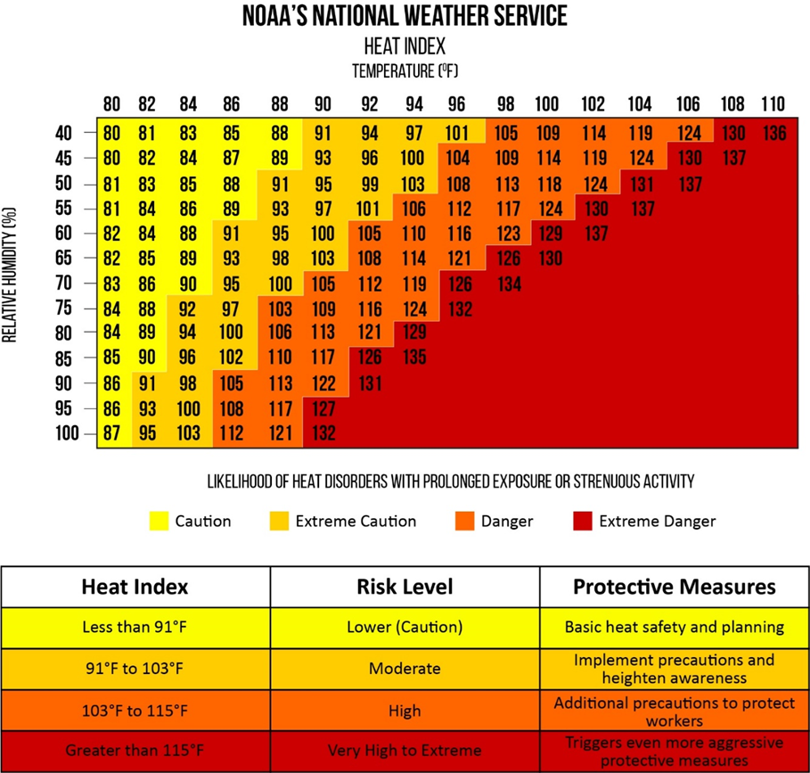

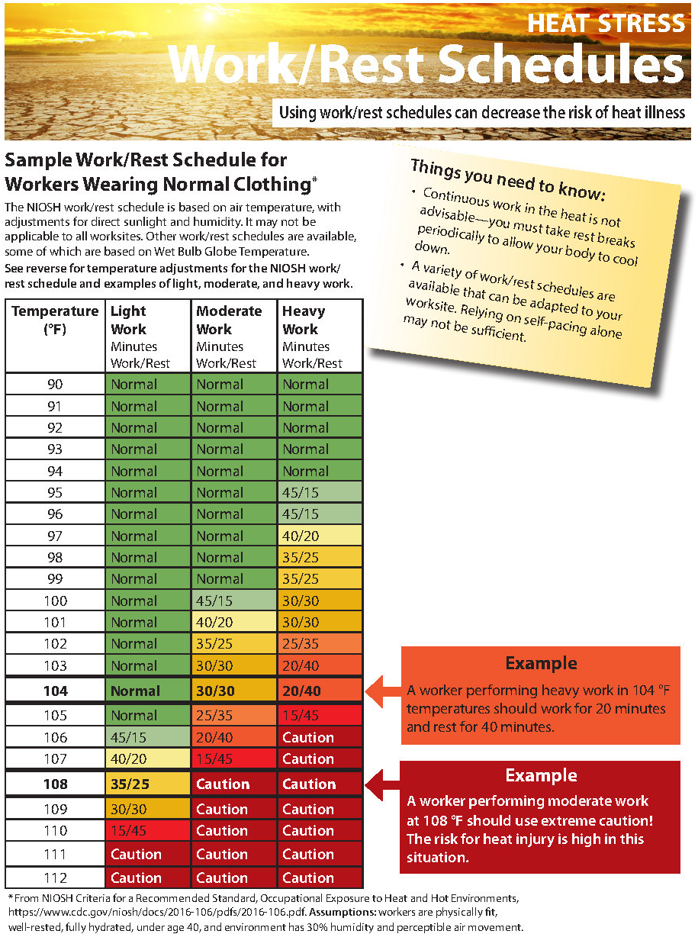
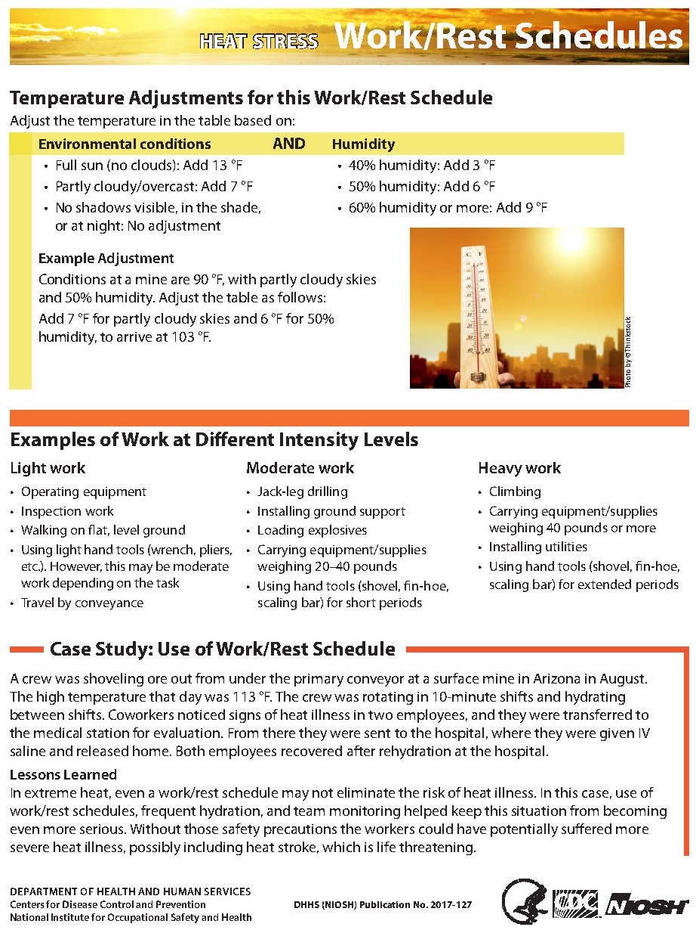
Appendix C: NIOSH WORK/REST SCHEDULE

