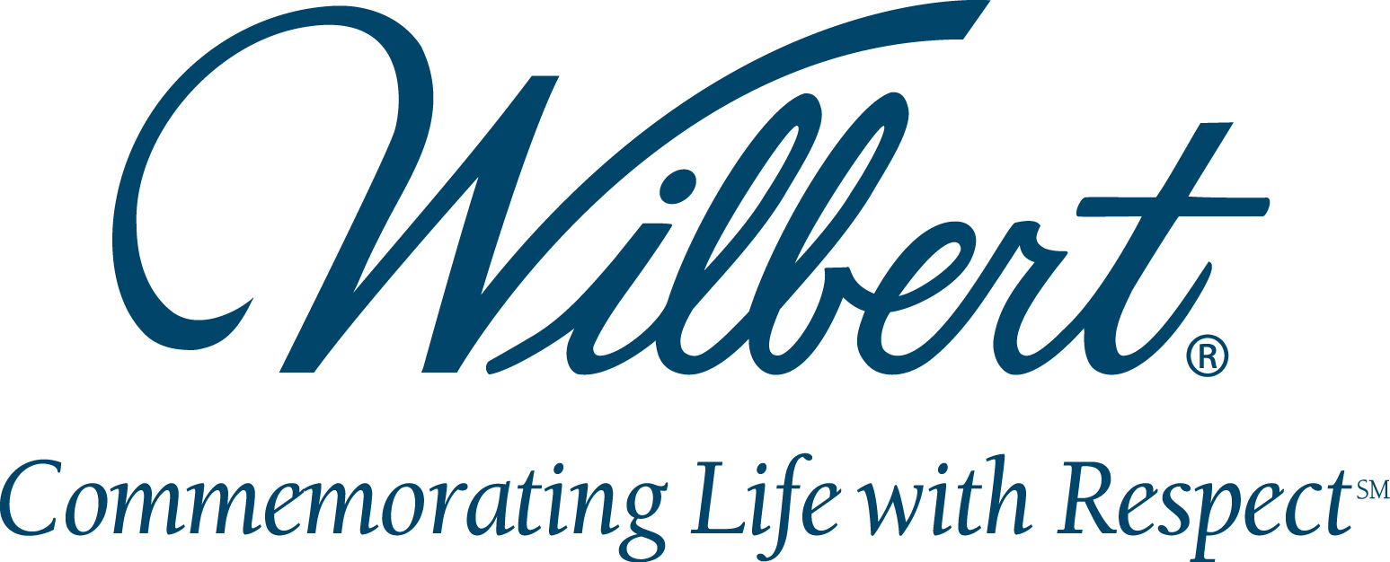

wilbert funeral services, Inc. promotes
Gabor gondocs to plant manager
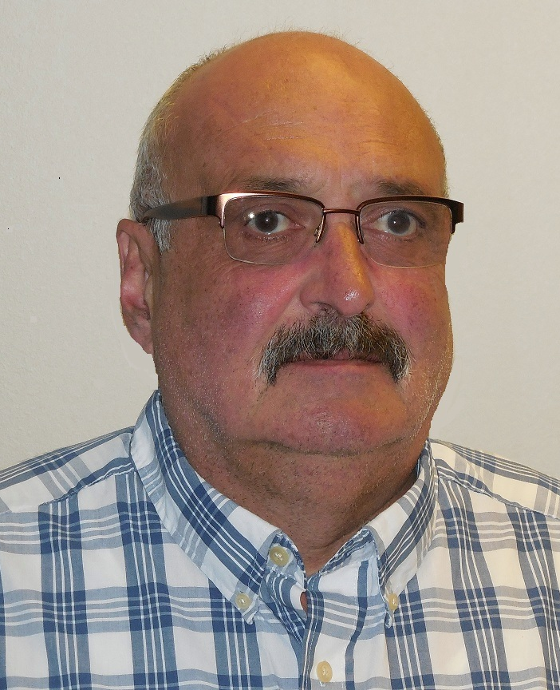

BROADVIEW, IL, NOVEMBER 5, 2013 – Wilbert Funeral Services, Inc. is pleased to announce the promotion of Gabor Gondocs to Plant Manager. In his position, Gondocs will be responsible for all manufacturing and distribution operations in the Wilbert corporate facility, located in Broadview, IL.
Gondocs has been with Wilbert Funeral Services, Inc. for 28 years, having joined the company in 1985 after immigrating to the United States from Hungary a year earlier. He has served Wilbert in numerous capacities beginning in the metal liner department and progressing to various supervisory positions in the miniature, concrete and bronze departments.
Gondocs holds a degree in Design and Control of Concrete Mixtures from the Portland Cement Association.
“Gabor has been a valued member of the manufacturing and distribution team, bringing many new ideas for efficiency over the course of his career at Wilbert,” said Michael Bogacki, Chief Operating Officer. “This is a well-deserved promotion and I am certain that he will excel in this position.”
Wilbert Funeral Services, Inc. is the leading single-source supplier of burial vaults and cremation-related products and services to North American funeral homes. For more information, call 888.WILBERT or visit www.wilbert.com.

