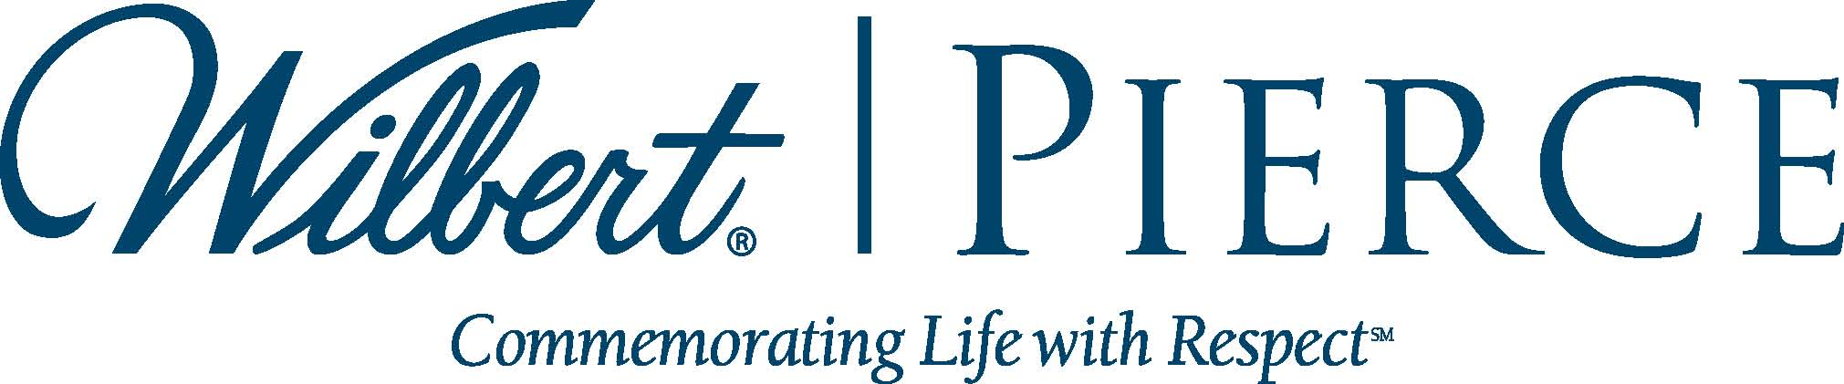
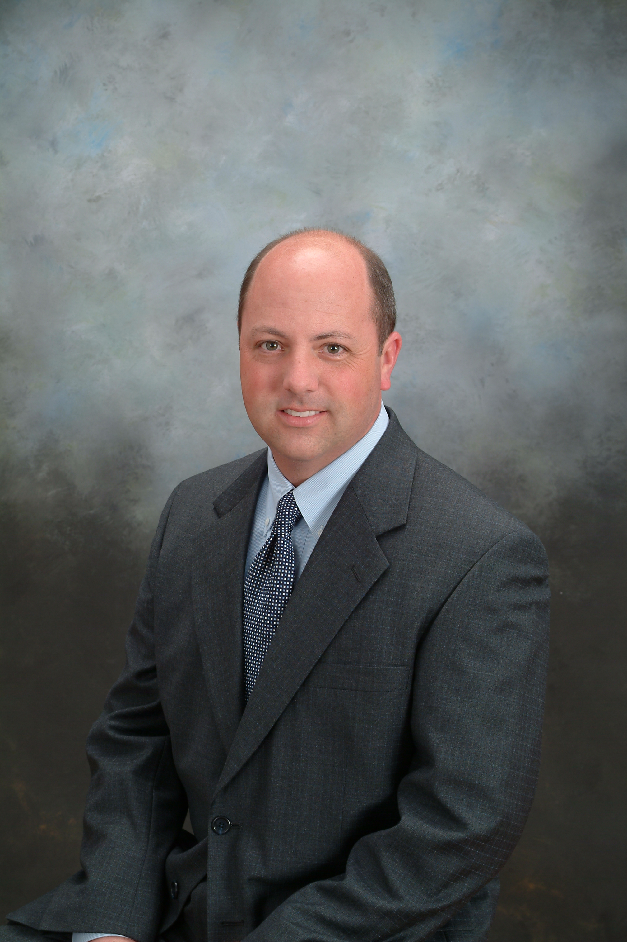

pierce chemical announces promotion of
lance ray to chief operating officer

BROADVIEW, IL, May 23, 2014 – Pierce Chemical today named Lance Ray as Chief Operating Officer of the company, effective immediately. Ray has served as Executive Vice-President of Sales at Pierce since December, 2012 when Wilbert Funeral Services, Inc. (WFSI) acquired the Dallas-based firm. Pierce Chemical operates autonomously under the WFSI umbrella.
John Firestone, past Chairman of the Board of Pierce, first made the announcement to Pierce employees, citing the solid transition that Lance Ray has helped foster since the acquisition.
Ray, who has overseen steady sales growth through a strengthened sales force, points to the support of the sales team and the entire Pierce staff as key to company’s continued success.
“I cannot say enough about the excellence of the Pierce team, from sales to customer service, to production and fulfillment and operations,” said Ray. “The company cannot succeed without the combined talents and contributions of every single employee and I have been honored to work with this fine group of people. I look forward to furthering our collective success with this dedicated team.”
Also an alumnus of Dallas Institute of Funeral Service, a Pierce Mortuary Colleges institution, as well as a licensed funeral director and embalmer, Ray has a long-time attachment to Pierce and its extensive line of chemicals and other products:
“Taking the position of COO of Pierce Chemical is such an amazing honor that I would never have envisioned as a mortuary science student back in 1994. This company has such a distinguished history of innovation and excellent products that I personally can attest to and I look forward to building on that strong heritage.”
To learn more about Pierce Chemical, visit www.piercechemical.com.

