PRESS RELEASE
Wayne Stellmach
Wilbert Funeral Services, Inc.
708-865-1600 x166
wstellmach@wilbert.com

Just in time for the holidays:
The Most Expensive Memorial jewelry Ever Created?

BROADVIEW, IL, November 20, 2013 – Memorial jewelry is typically not in the luxury jewelry category…until now.
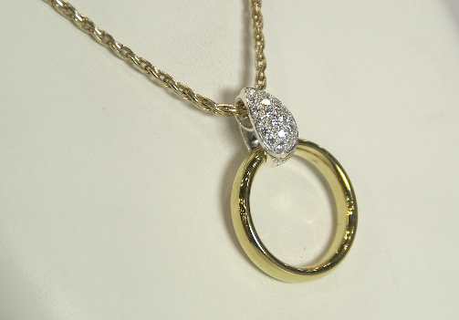
A Ringuardian™ with over 20 brilliant diamonds set in white gold on a 14-carat gold necklace is an elegant piece custom-designed by the renowned Lester Lampert Jewelers of Chicago for Wilbert Funeral Services, Inc. With a retail price of over $5,000, this one-of-a-kind creation is crafted to hold a wedding or any heirloom ring, keeping the memory of a loved one close to one’s heart.
While the standard Ringuardian is generally chosen as a unique piece at an affordable price, some people have expressed a desire for a luxurious customized piece that is truly special.
“We’ve designed thousands of jewelry pieces for discriminating customers,” said Lester Lampert, owner of Lester Lampert Jewelers, “but in working with Wilbert Funeral Services have come to appreciate that people want to treasure memories of their loved ones – and there are some who wish for one-of-a-kind, sophisticated pieces such as this custom-designed Ringuardian.”
Memorial jewelry is typically designed to hold cremated remains, but the Ringuardian is different in that it holds a ring - appealing to anyone who may be keeping a keepsake ring out of sight, stuck in a drawer, because while they don’t want to part with it, they also don’t know what to do with it. The Ringuardian is the solution.
The customized Ringuardian can be made from any precious metal such as white or yellow gold or platinum to suit a consumer’s particular style. The type and size of the jewels are left to the individual, using diamonds or other jewels either acquired specifically for the Ringuardian or re-set from another piece of jewelry. This customization allows consumers to create one-of-a-kind pieces that will memorialize their loved ones for years.
The Ringuardian does not damage or alter the ring in any way. It wraps around the ring so it is securely protected, and the design allows the ring to be effortlessly removed at any time, providing cherished rings with constant protection and giving peace of mind to the wearer that the ring will not be lost or damaged while in use as a necklace.
The Ringuardian is available through funeral homes carrying the Wilbert line of jewelry. To locate one near you, email Wilbert at moreinfo@wilbert.com.
To learn more about the Ringuardian – and to hear the fascinating story behind it from the designer herself – watch this video at wilbert.com/ringuardian-story.

