
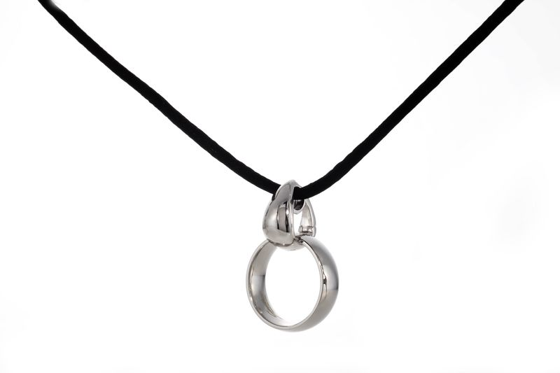

innovative memorialization jewelry piece unveiled by WILBERT

BROADVIEW, IL, June 7, 2013 – “What do I do with the ring?”, the perennial question often heard by funeral professionals, is now beautifully solved with the Ringuardian™, a unique jewelry device just introduced by Wilbert Funeral Services.

Crafted in solid sterling silver, the Ringuardian holds a wedding ring so it may be worn as an exquisite remembrance necklace. Wrapping around the ring without damaging or altering it in any way, the Ringuardian securely protects the keepsake ring while attractively displaying it and keeping it close to the heart.

When a loved-one dies he or she leaves behind a few, very precious personal possessions – arguably one of the most precious is the wedding ring. Whether inherited by the surviving spouse or another close family member, this ring is cherished and passed down through the generations.

“The Ringuardian is a welcome solution for everyone,” states Mike Devaney, Cremation Merchandising Manager for Wilbert Funeral Services. “Whether the loss of a loved one was recent or 50 years ago, this is a way to bring the ring out of a drawer and affectionately remember your loved one.”

The Ringuardian is designed by the renowned Lester Lampert Jewelers, who creates many elegant memorialization jewelry pieces for Wilbert.

To learn more, or to get Ringuardian brochures for your funeral home, contact your local Wilbert Licensee. You can also see more details on wilbert.com or wilbertdirect.com.

